ASSUMPTION UNIVERSITY



**CE3002 Commercial Application Program**

**Project Report**

**(Paint software)**

Submitted by: Nyi Nyi Myo Zin Htet

ID: 5918154

Section: 641

1. **Introduction**

Paint project that can draw things freehand, draw line, generate Text and erase what we draw.

This paint software also can open any picture and draw on the picture.

There are 8 main tools in this java paint software has.

They are (1) Draw which we can draw anything we want

(2) Rubber which can erase what we drew

(3) Line which we can draw a straight line

(4) Text which we can type and generate

(5) Line Color which can choose any color we want

This is a window when the application start

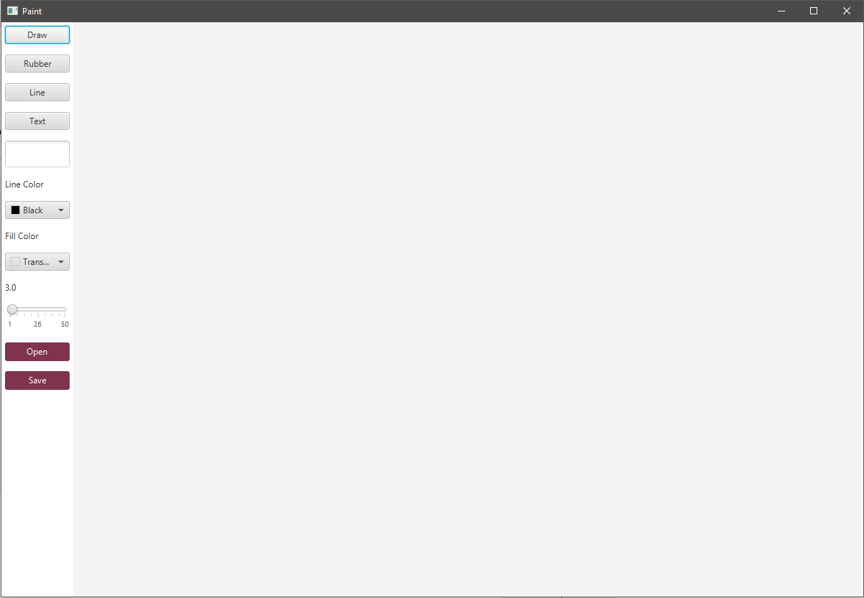

Select draw to freehand drawing.

In this picture draw was selected and drew a freehand drawing.

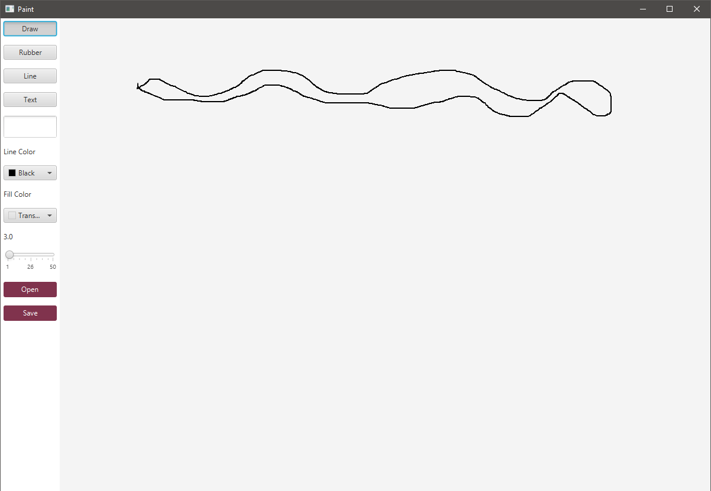

Line was selected and drew multiple lines

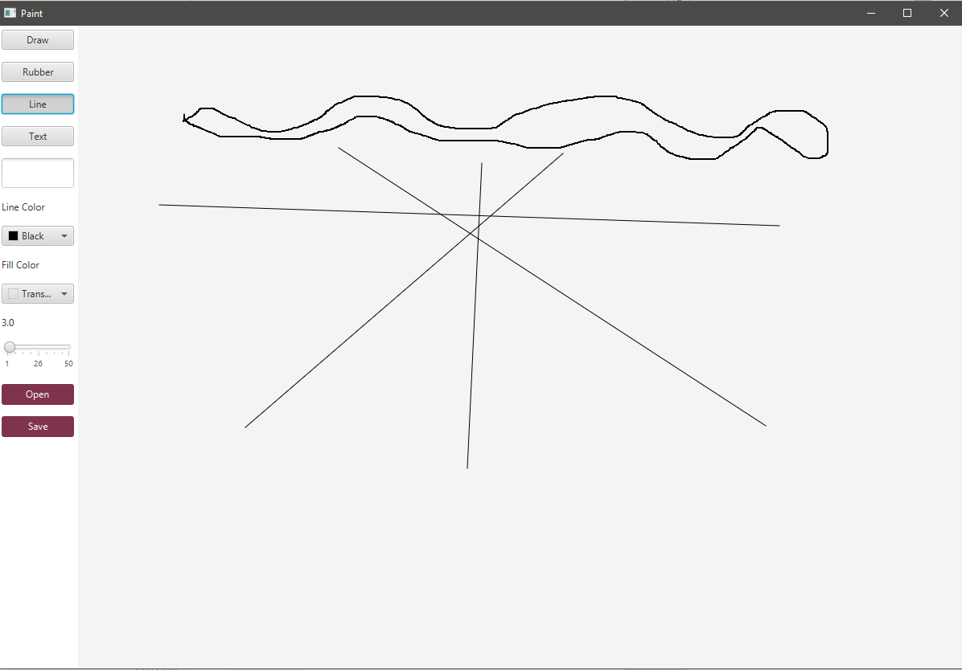

Write anything in the text box to generate the text we want

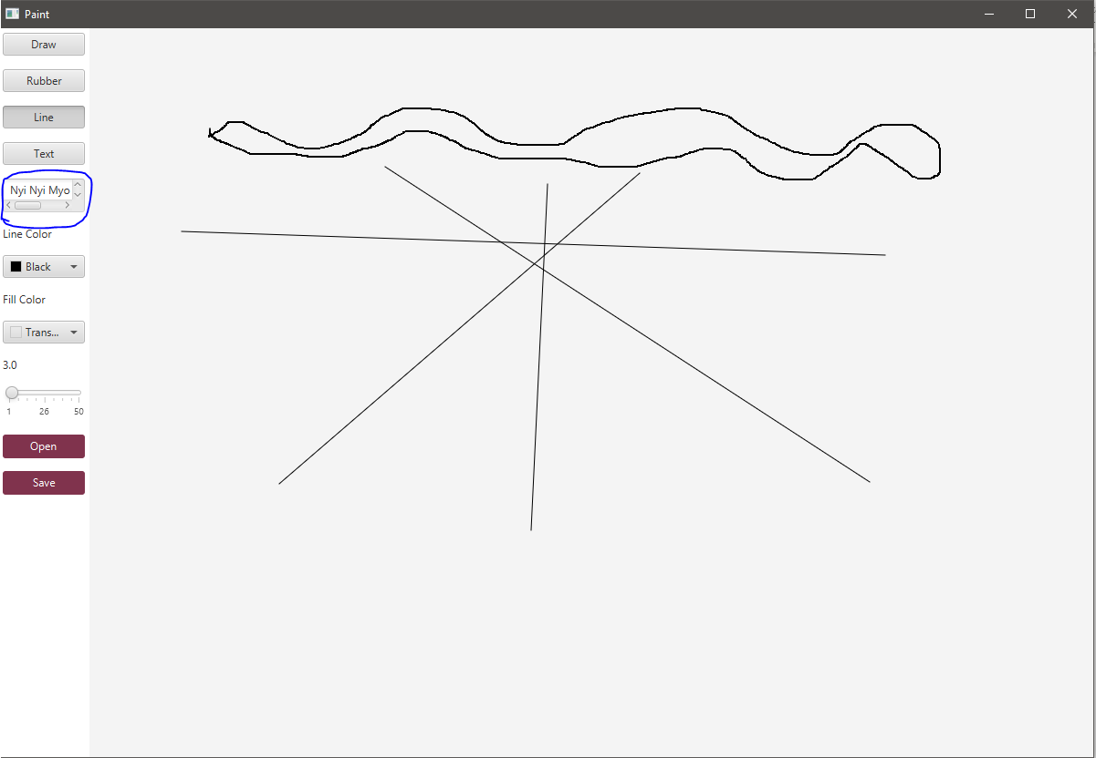

Select Text to generate what we typed in the text box.

Choose the size by moving the slider above the open button. Move right to make the size bigger.

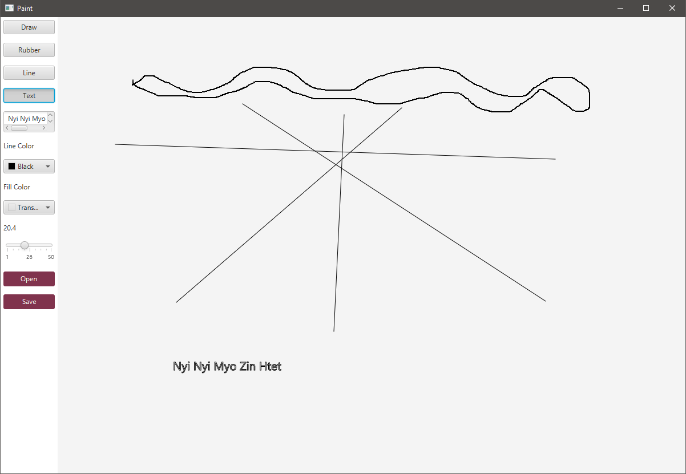

Select Rubber to erase what we drew or text what we generated.

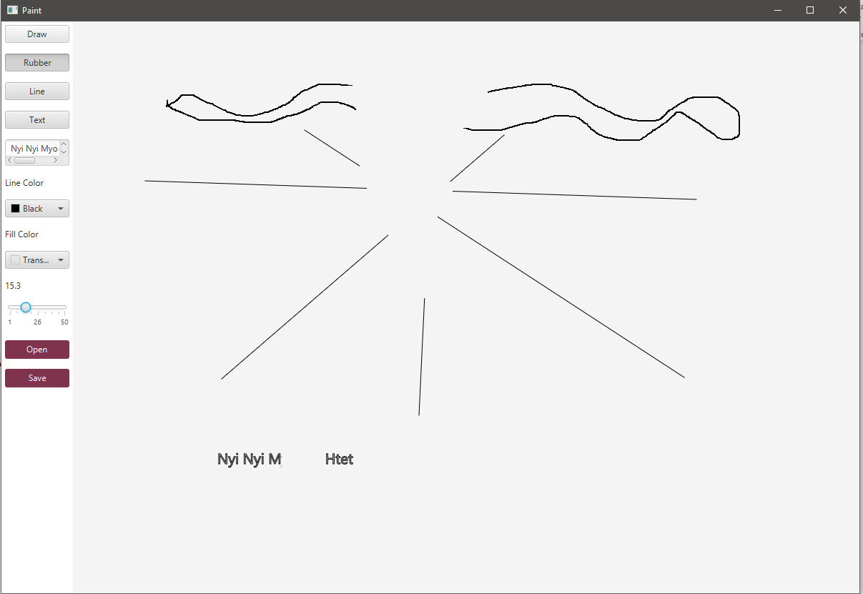

Choose color by selecting the square box under the Line color and Fill Color

Fill Color is only for the text and Line color is for both freehand drawing and drawing line.

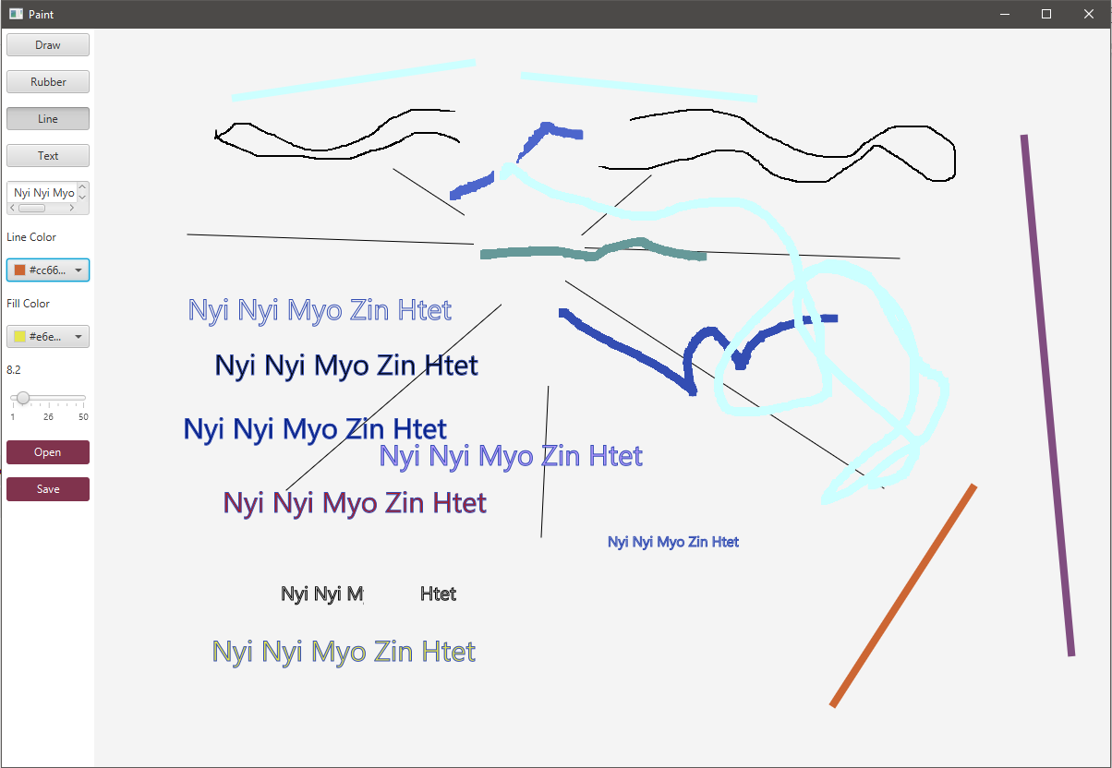

Can choose more colors by clicking custom color

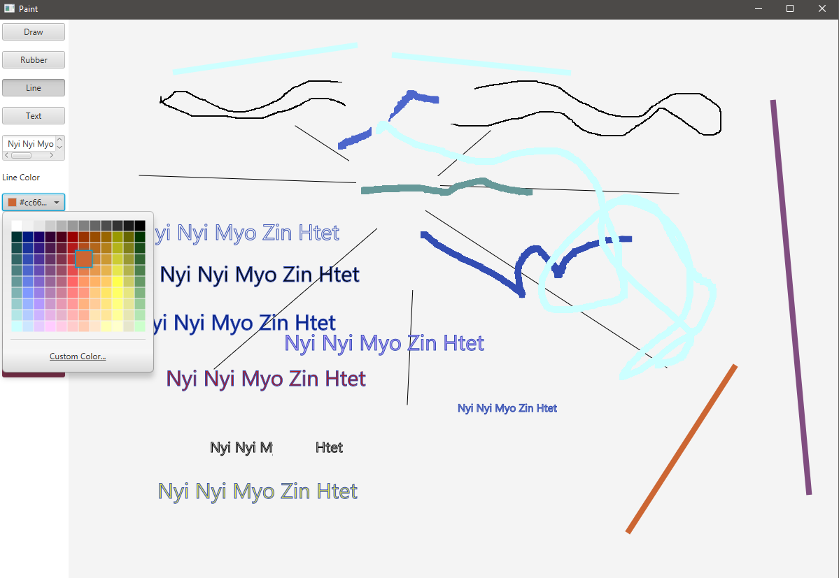

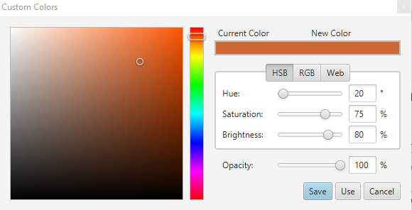

Save what we drew by typing “name.png” to save as picture.

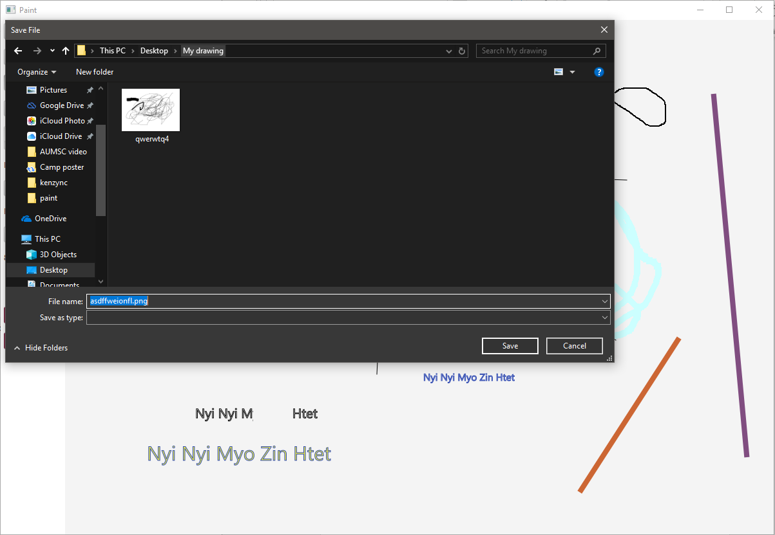

This is the picture what I give example and drew.

